**MA 374 - Financial Engineering Lab07**

**Sahil Kumar Gupta**

**200123081**

**Q1**

Formula used for calculating the Put and Call option price in the classical BSM framework using Black-Scholes-Merton PDE is:

$\begin{matrix}C(s,t)= & sN\left(d_{1}\right)-Ke^{-r(T-t)}N\left(d_{2}\right) \\ P(s,t)= & Ke^{-r(T-t)}N\left(-d_{2}\right)-sN\left(-d_{1}\right)\end{matrix}$ where,

$$\begin{matrix} & d_{1}=\frac{log⁡\left(\frac{s}{K}\right)+\left(r+\frac{1}{2}σ^{2}\right)(T-t)}{σ\sqrt{T-t}} \\ & d_{2}=\frac{log⁡\left(\frac{s}{K}\right)+\left(r-\frac{1}{2}σ^{2}\right)(T-t)}{σ\sqrt{T-t}} \\ & N(x)=\frac{1}{\sqrt{2π}}\int_{-∞}^{x}{ } e^{-\frac{1}{2}y^{2}}dy\end{matrix}$$

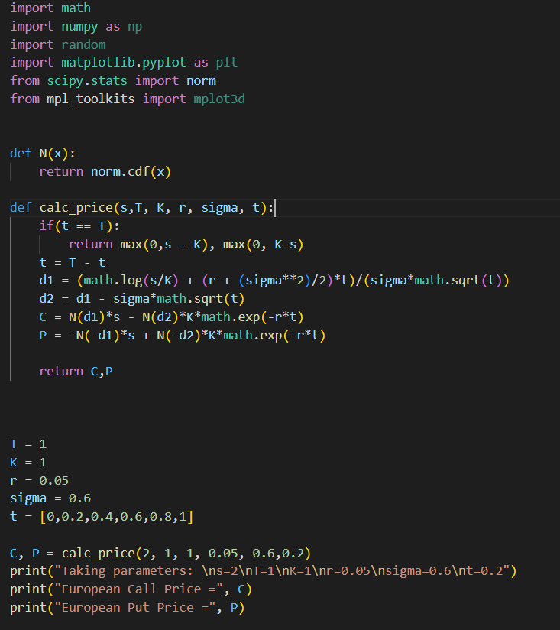Function written to compute the required prices in this question is:

**Q2**

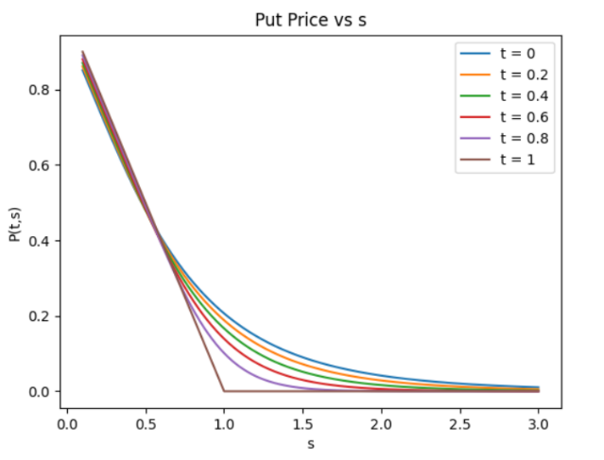Using the given values of the parameters as given in the question and the function written in previous question, plot of C(t,s) and P(t,s) as a function of *s* for different values of *t* is obtained s:

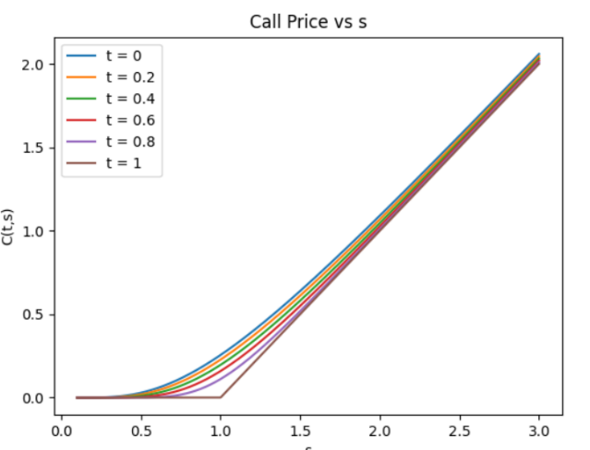

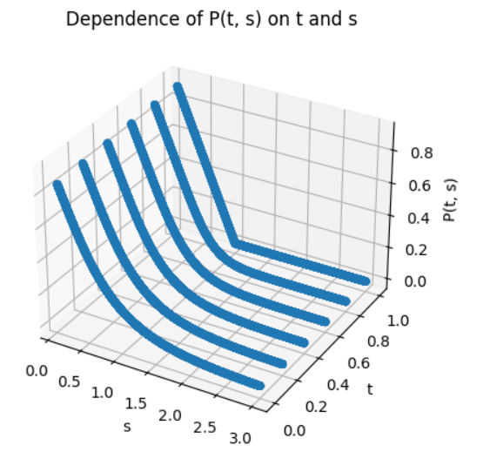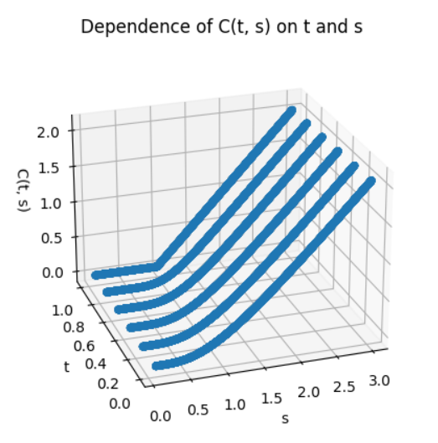Showing the same information in 3-dimensional form:

**Q3**

Required plots of C(t,s) and P(t,s) as smooth surface above the (t,s)-plane:

The parameter values are adjusted as needed, and when specific parameter values are needed, they are obtained 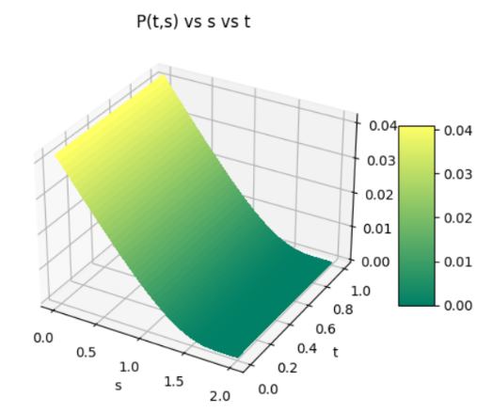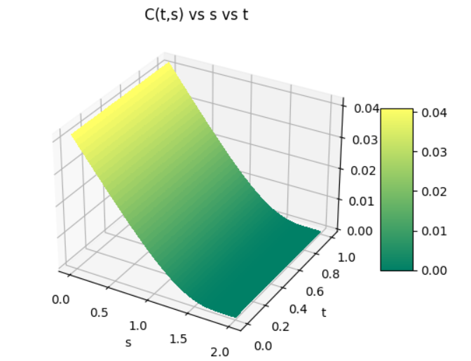as:

$$T=1,K=1,r=0.05,σ=0.6$$

**Q4**

The parameter values are adjusted as needed, and when specific parameter values are needed, they are obtained as:

$$s=2, t=0.4, T=1,K=1,r=0.05,σ=0.6$$

**Variation of C(t,s) and P(t,s) with Stock Price (s):**

This is case is already covered in Q2 and Q3

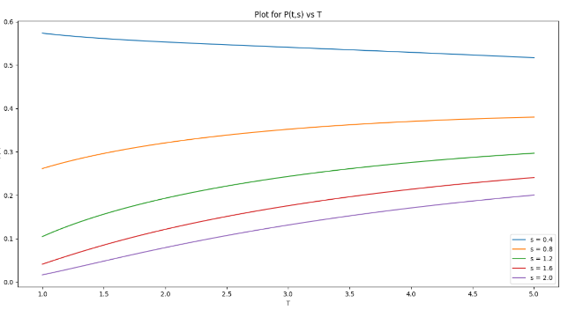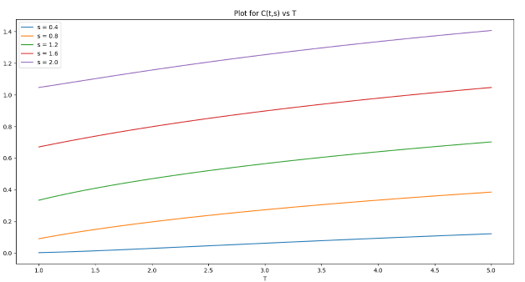**Variation of C(t,s) and P(t,s) with Expiration Time (T):**

Some of the values are: (with parameters as $x=2,t=0.4,K=1,r=0.05$ and $σ=0.6$)

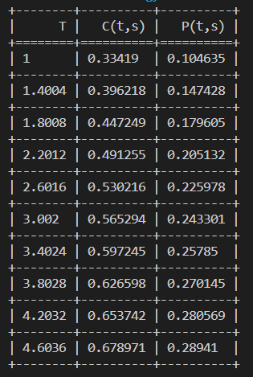

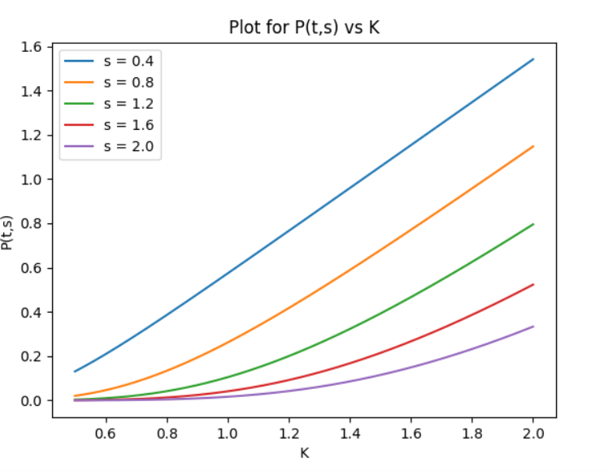**Variation of C(t,s) and P(t,s) with Strike Price (K):**

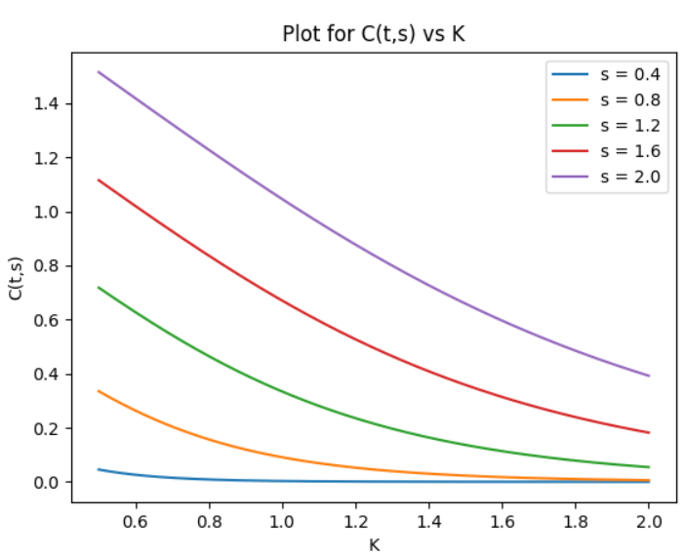

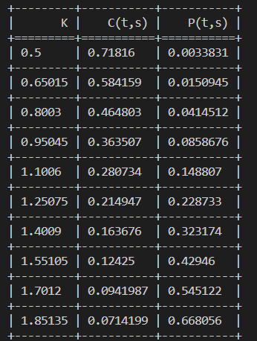Some of the values are: (with parameters as and )

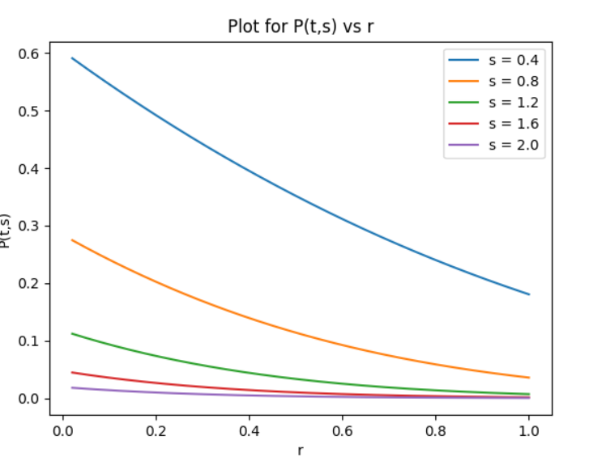**Variation of C(t,s) and P(t,s) with Rate of Interest (r):**

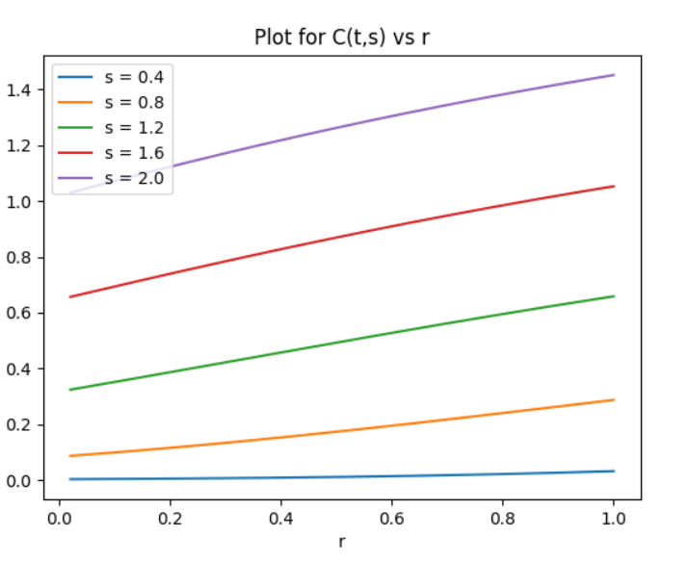

Some of the values are: (with parameters as $x=2,t=0.4,K=1,r=0.05$ and $σ=0.6$)

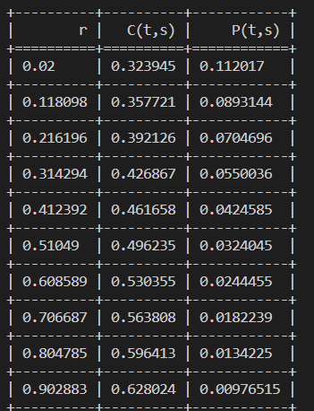

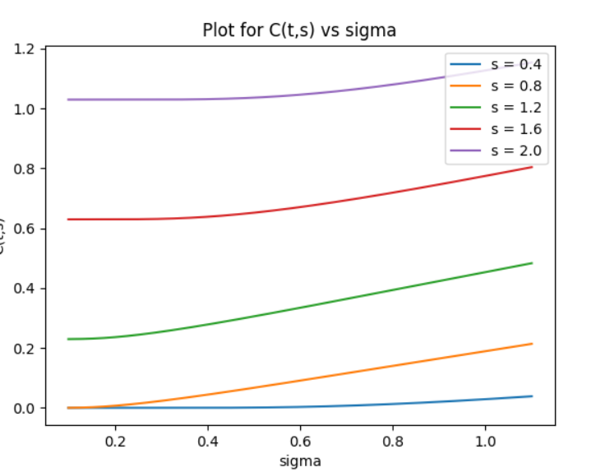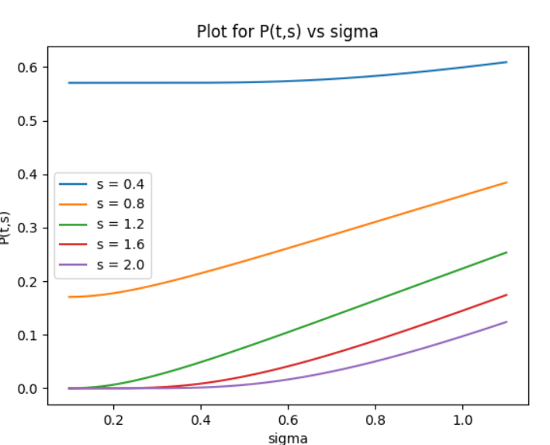**Variation of C(t,s) and P(t,s) with Volatility (sigma):**

Some of the values are: (with parameters as $x=2,t=0.4,K=1,r=0.05$ and $σ=0.6$)

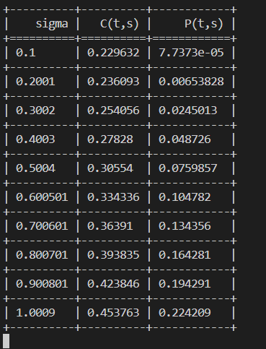

**Variation of C(t,s) and P(t,s) with Stock Price (s) and Expiration Time (T):**

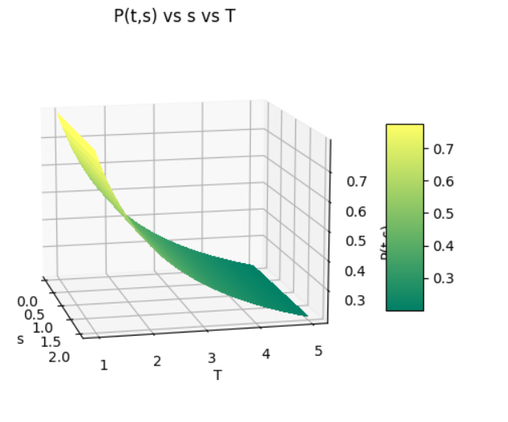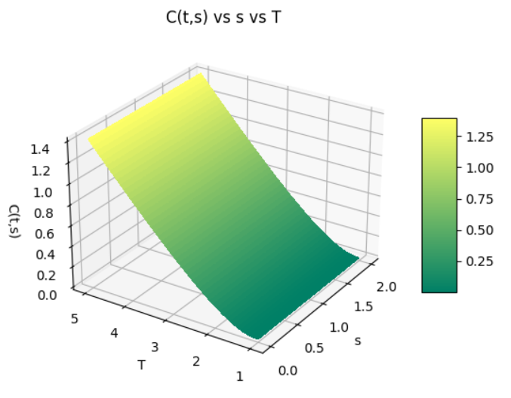

**Variation of C(t,s) and P(t,s) with Stock Price (s) and Strike Price (K):**

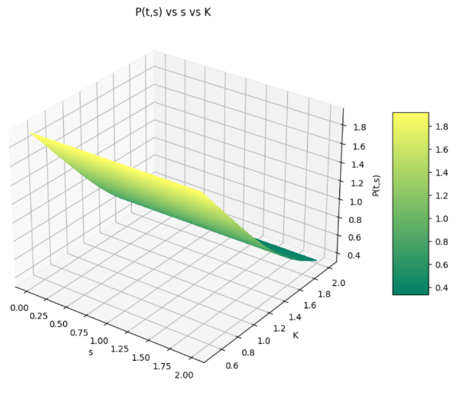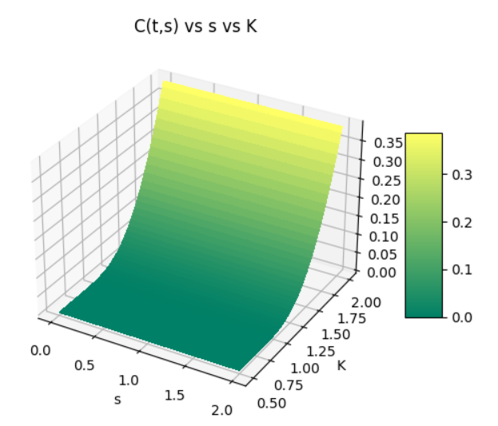

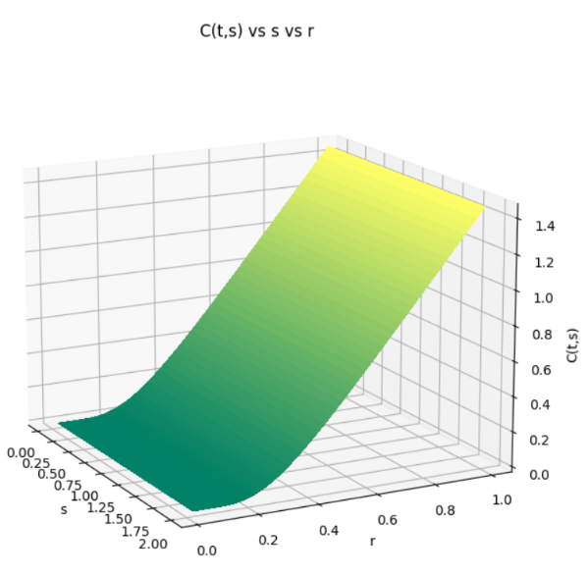**Variation of C(t,s) and P(t,s) with Stock Price (s) and Rate of Interest (r):**

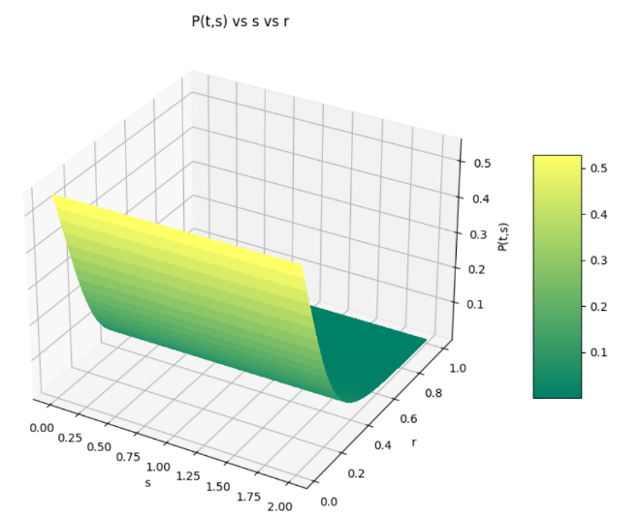

**Variation of C(t,s) and P(t,s) with Stock Price (s) and Volatility (sigma):**

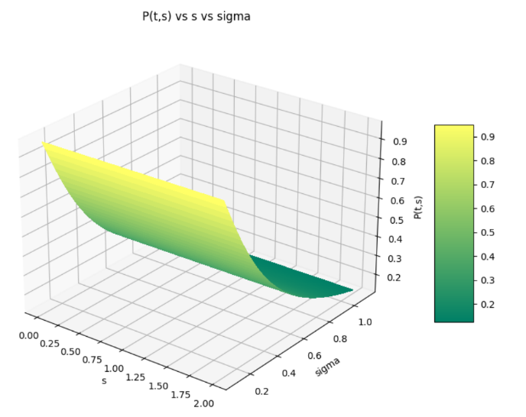

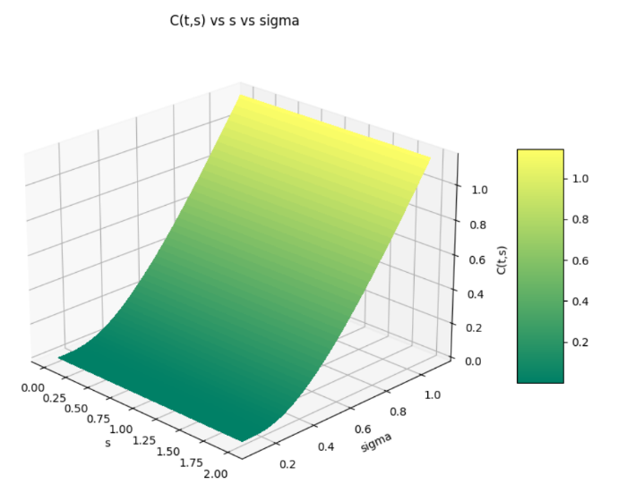

**Variation of C(t,s) and P(t,s) with Expiry Time (T) and Strike Price (K):**

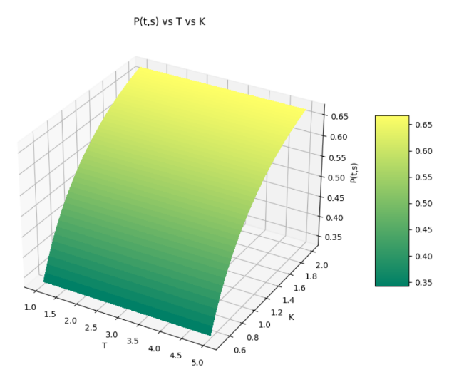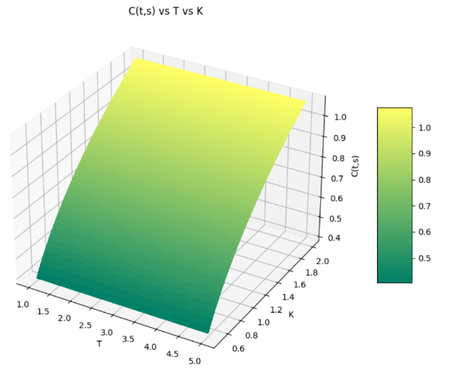

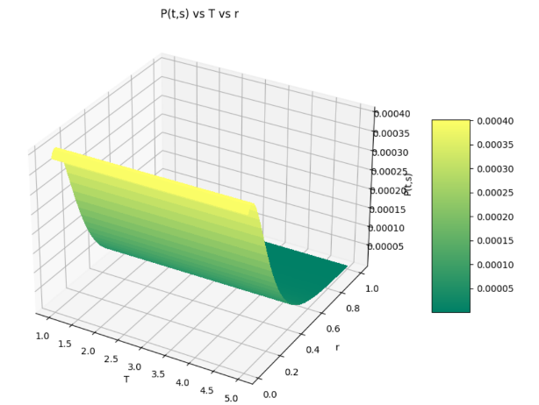**Variation of C(t,s) and P(t,s) with Expiry Time (T) and Rate of Interest (r):**

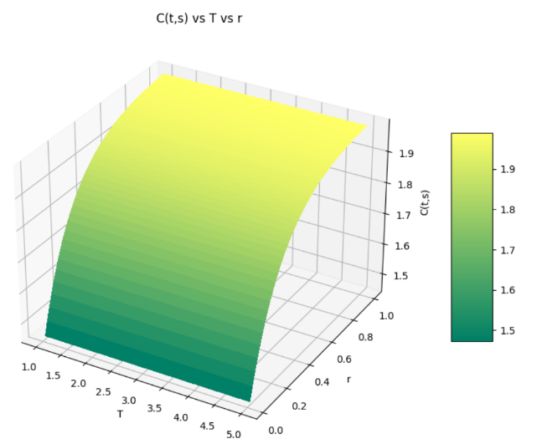

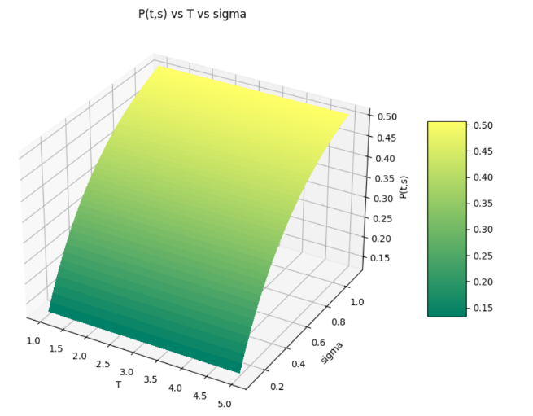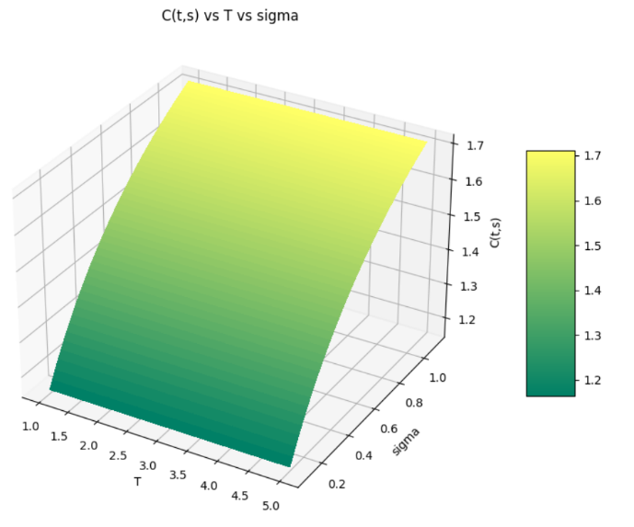**Variation of C(t,s) and P(t,s) with Expiry Time (T) and Volatility (sigma):**

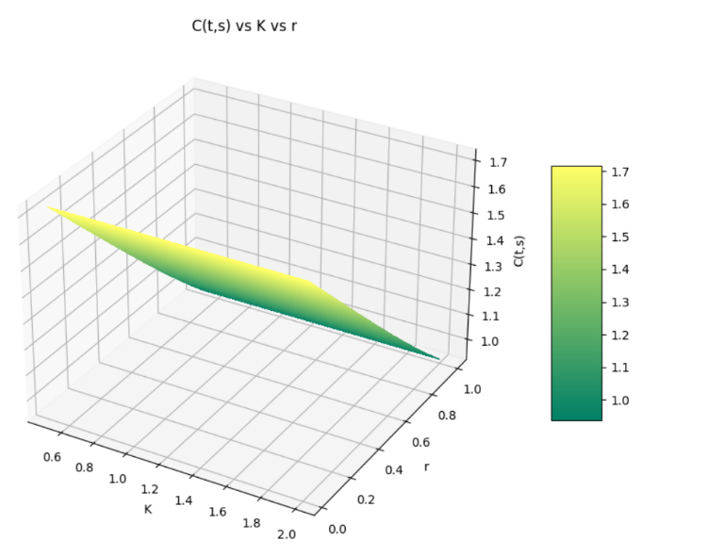**Variation of C(t,s) and P(t,s) with Strike Price (K) and Rate of Interest (r):**

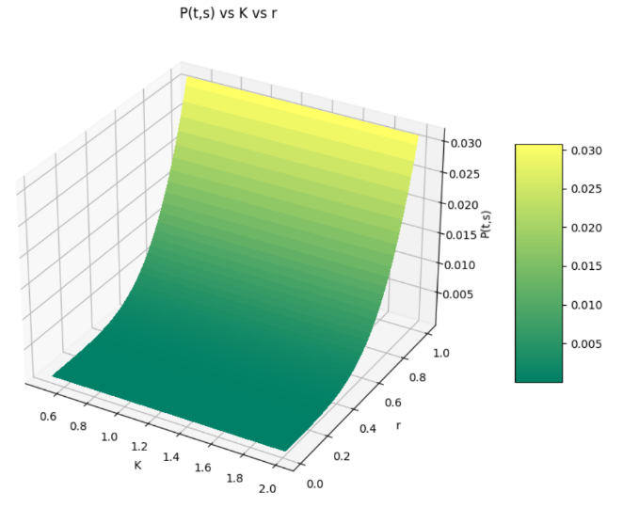

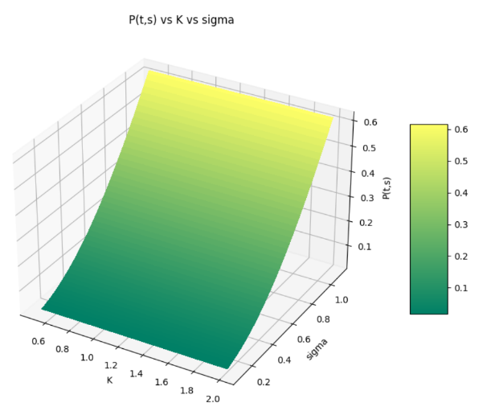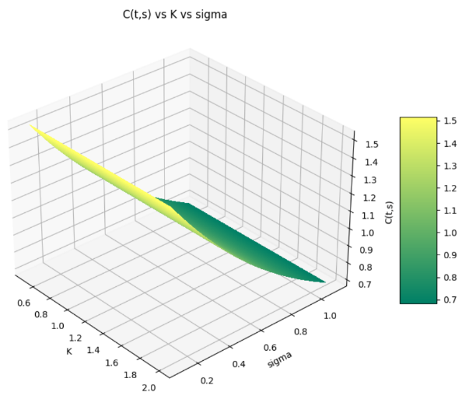**Variation of C(t,s) and P(t,s) with Strike Price (K) and Volatility (sigma):**

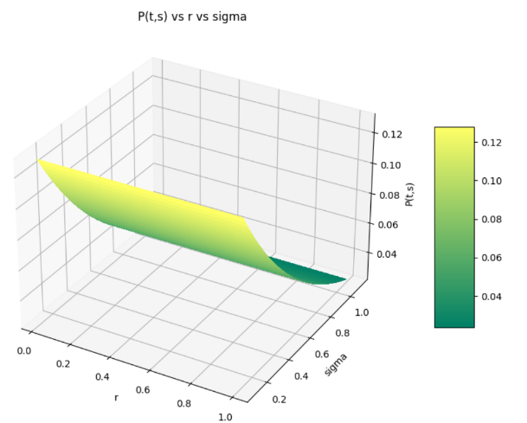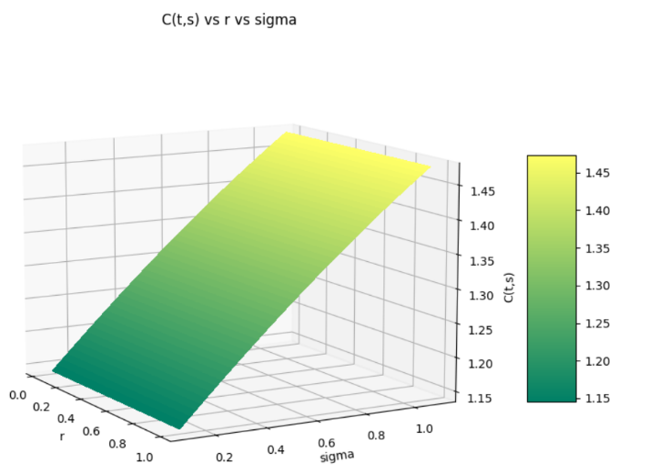**Variation of C(t,s) and P(t,s) with Rate of interest (r) and Volatility (sigma):**

**Q5**

Formula used for calculating the Put and Call option price in the classical BSM framework with dividend paying stocks is:

$\begin{matrix}C(s,t)= & se^{-a(T-t)}N\left(d_{1}\right)-Ke^{-r(T-t)}N\left(d_{2}\right) \\ P(s,t)= & Ke^{-r(T-t)}N\left(-d_{2}\right)-se^{-a(T-t)}N\left(-d_{1}\right)\end{matrix}$ where,

$$\begin{matrix} & d_{1}=\frac{log⁡\left(\frac{s}{K}\right)+\left(r-a+\frac{1}{2}σ^{2}\right)(T-t)}{σ\sqrt{T-t}} \\ & d_{2}=\frac{log⁡\left(\frac{s}{K}\right)+\left(r-a-\frac{1}{2}σ^{2}\right)(T-t)}{σ\sqrt{T-t}} \\ & N(x)=\frac{1}{\sqrt{2π}}\int_{-∞}^{x}{ } e^{-\frac{1}{2}y^{2}}dy\end{matrix}$$

The parameter values are adjusted as needed, and when specific parameter values are needed, they are obtained as:

$s=2, t=0.4, T=1,K=1,r=0.05,σ=0.6$, a = 0.3

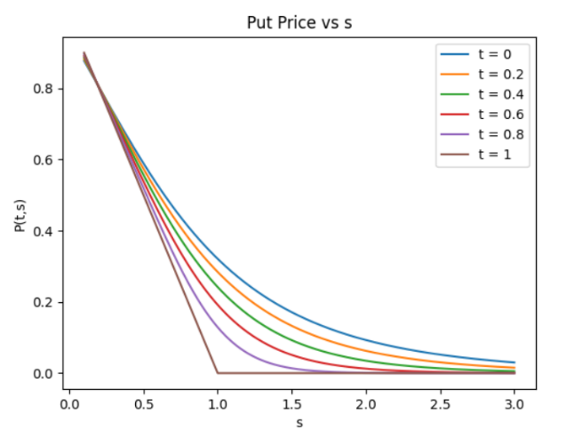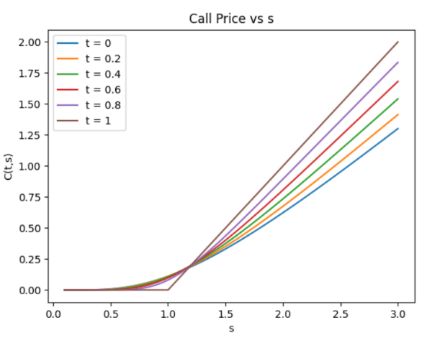**Variation of C(t,s) and P(t,s) with Stock Price (s):**

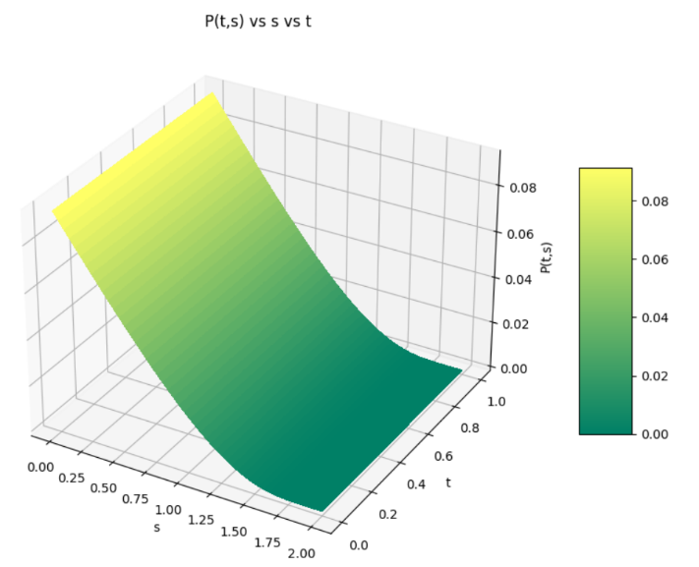

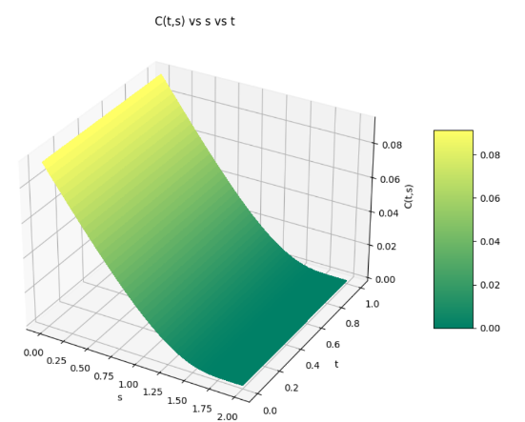

**Variation of C(t,s) and P(t,s) with Expiration Time (T):**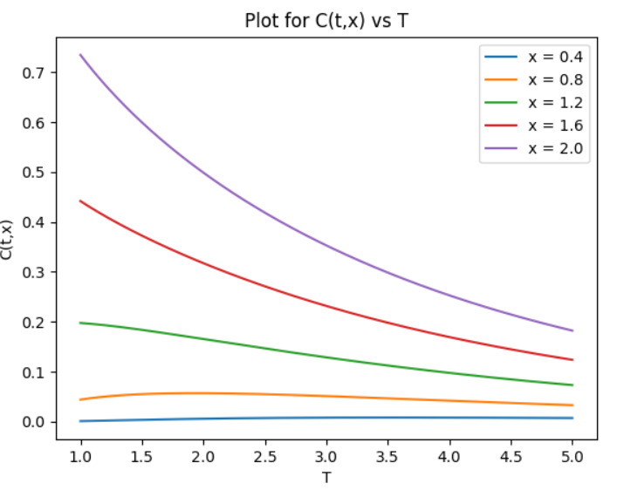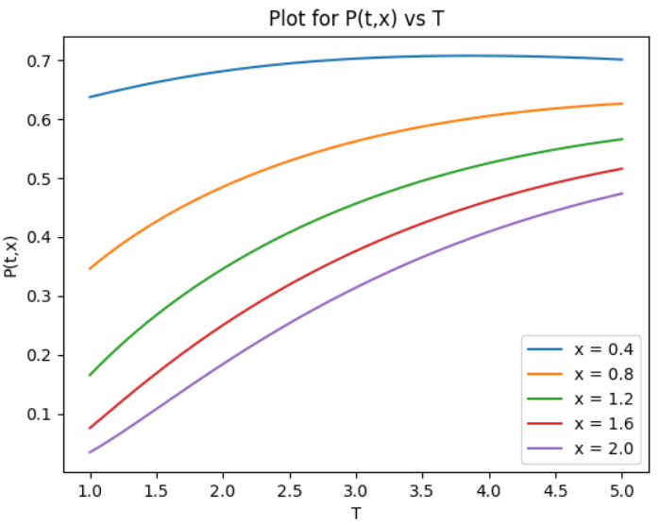

Some of the values are: (with parameters as $x=2,t=0.4,K=1,r=0.05$ and $σ=0.6, a = 0.3$)

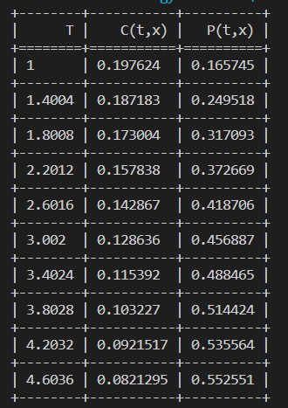

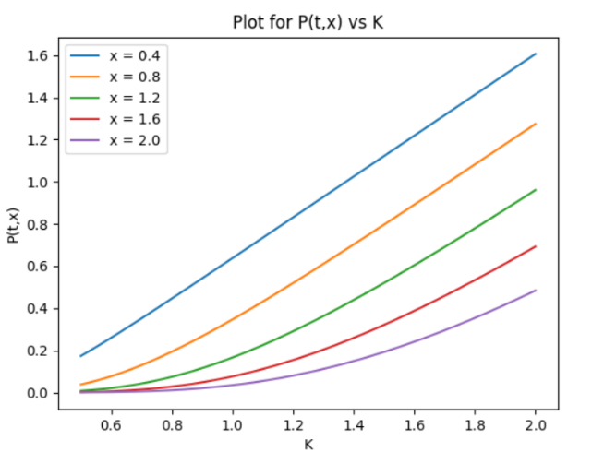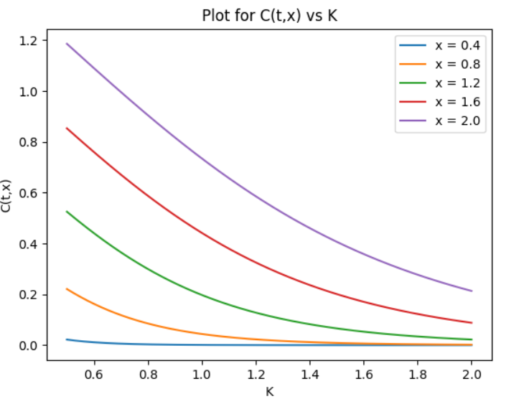**Variation of C(t,s) and P(t,s) with Strike Price (K):**

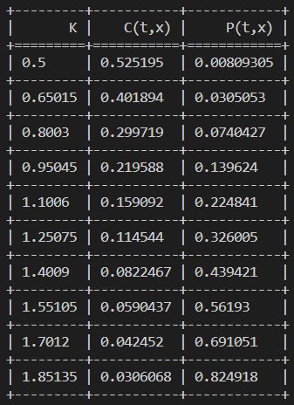Some of the values are:(with parameters as and )

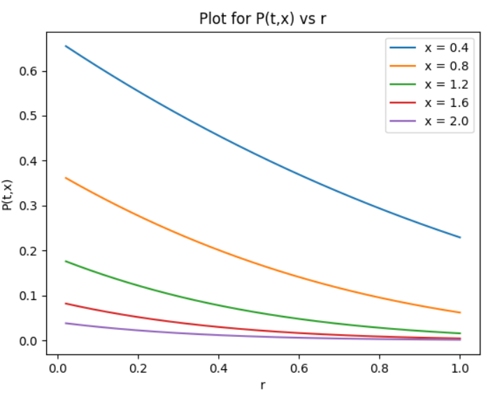**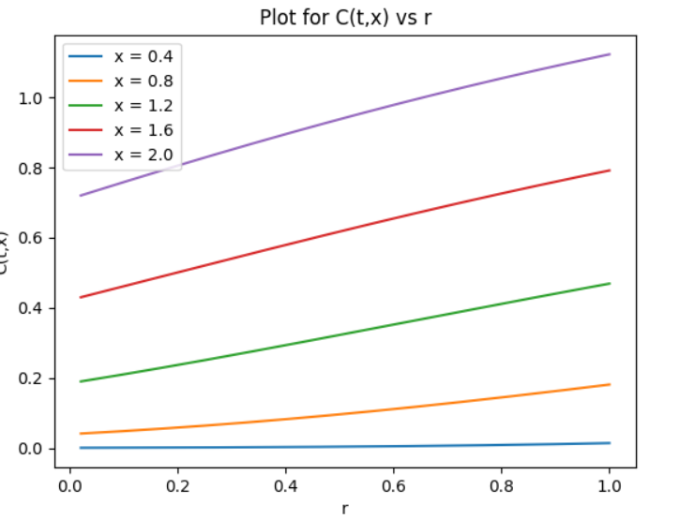Variation of C(t,s) and P(t,s) with Rate of Interest (r):**

Some of the values are: (with parameters as $x=2,t=0.4,K=1,r=0.05$ and $σ=0.6, a = 0.3$)

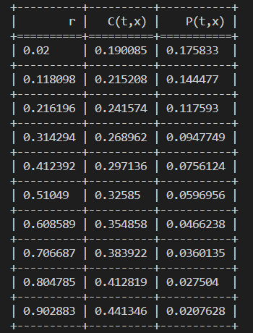

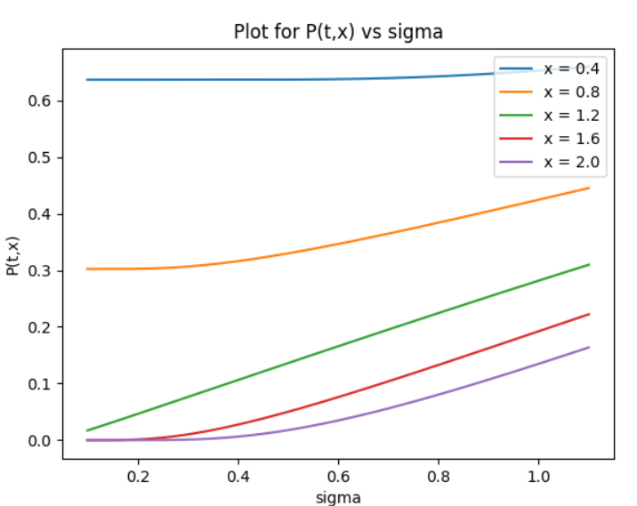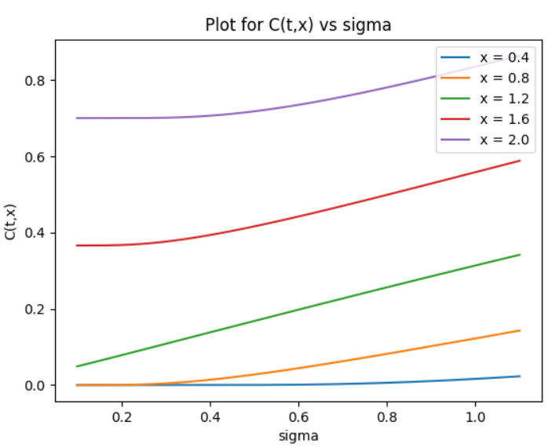**Variation of C(t,s) and P(t,s) with Volatility (sigma):**

Some of the values are: (with parameters as $x=2,t=0.4,K=1,r=0.05$ and $σ=0.6$, a = 0.3)

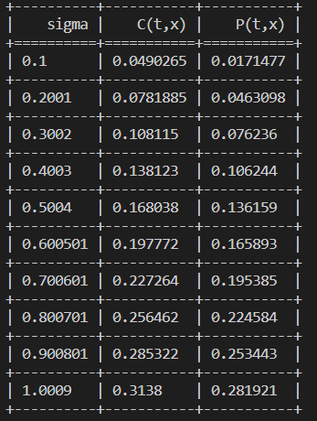

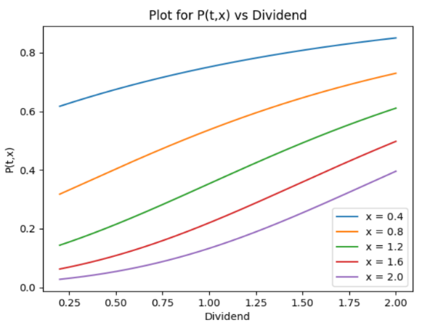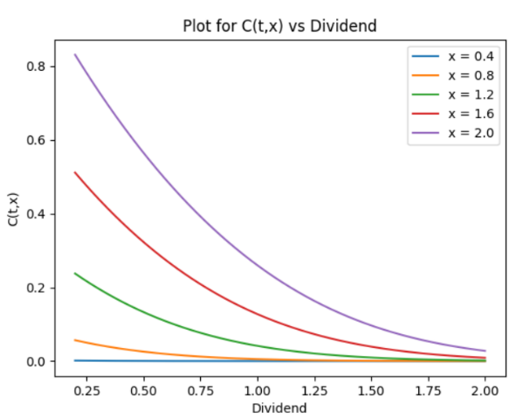**Variation of C(t,s) and P(t,s) with Dividend (a):**

Some of the values are: (with parameters as $x=2,t=0.4,K=1,r=0.05$ and $σ=0.6$, a = 0.3)

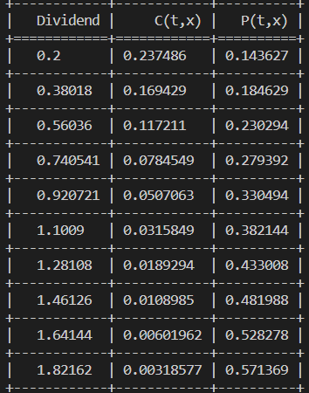

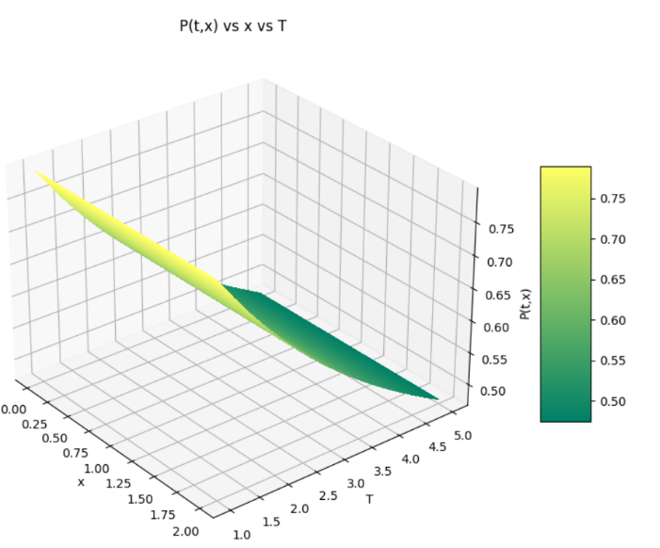**Variation of C(t,s) and P(t,s) with Stock Price (s) and Expiration Time (T):**

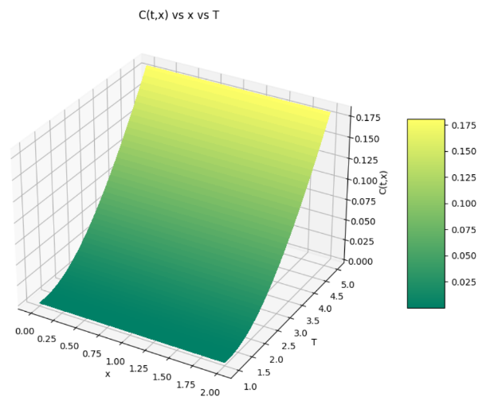

**Variation of C(t,s) and P(t,s) with Stock Price (s) and Strike Price (K):**

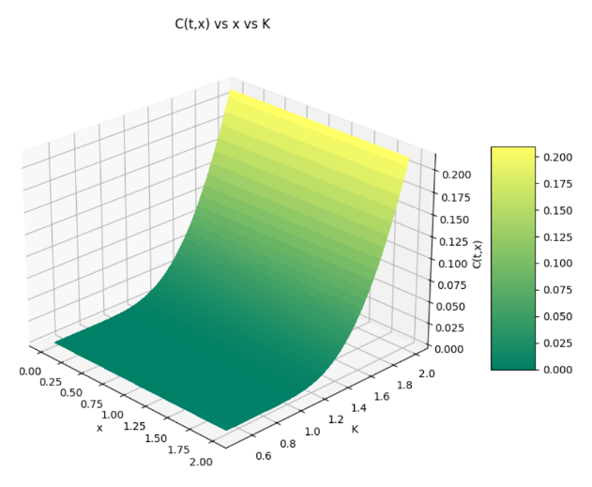

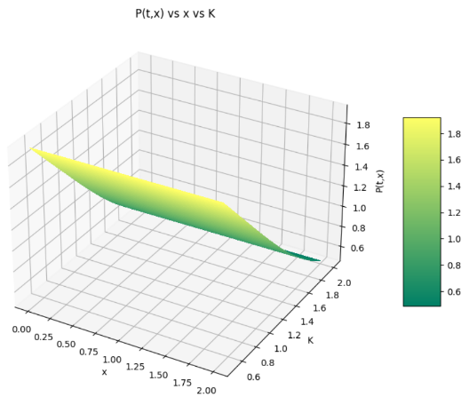

**Variation of C(t,s) and P(t,s) with Stock Price (s) and Rate of Interest (r):**

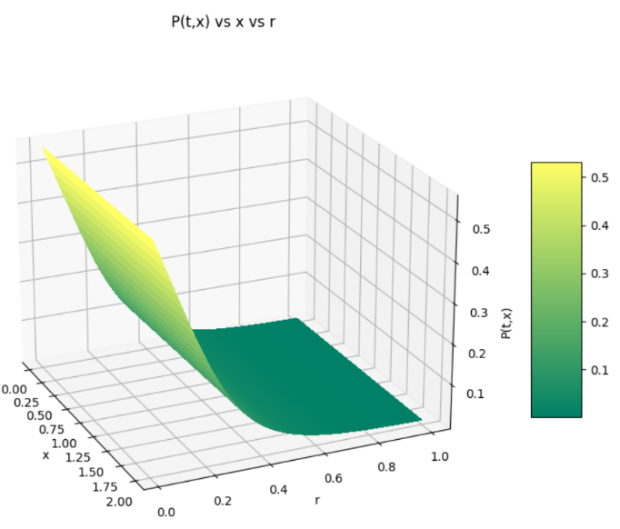 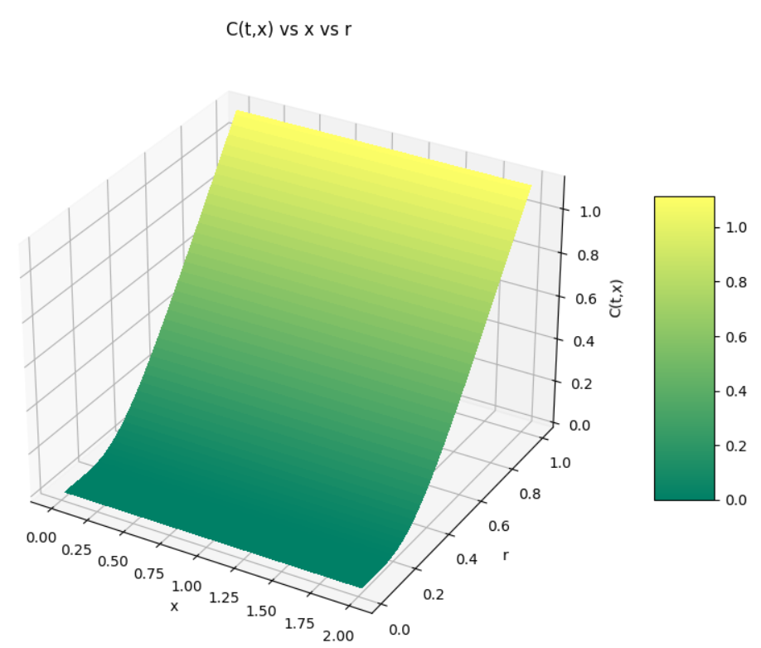

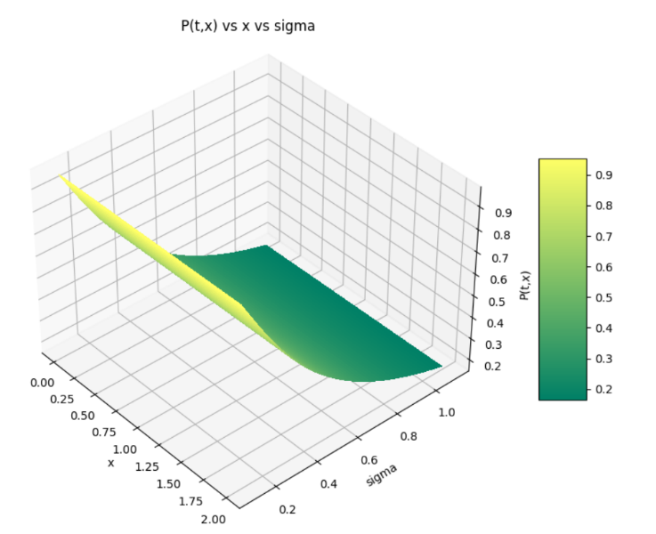**Variation of C(t,s) and P(t,s) with Stock Price (s) and Volatility (sigma):**

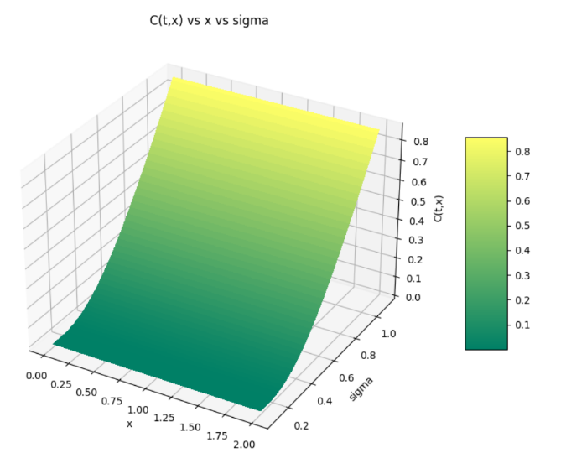

**Variation of C(t,s) and P(t,s) with Stock Price (s) and Dividend (a):**

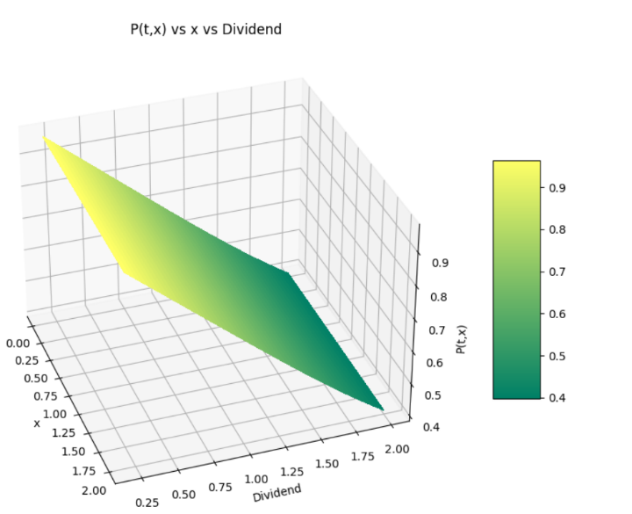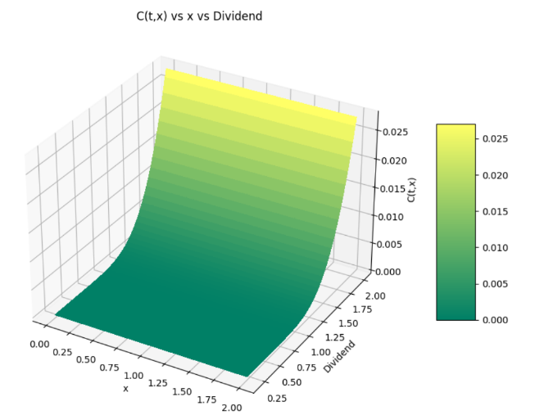

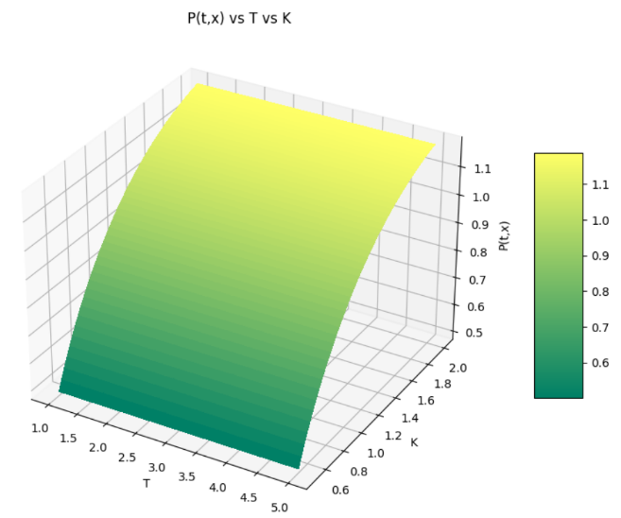**Variation of C(t,s) and P(t,s) with Expiry Time (T) and Strike Price (K):**

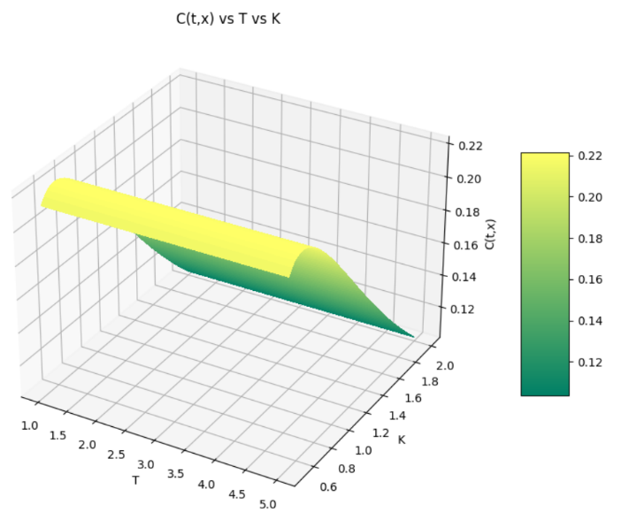

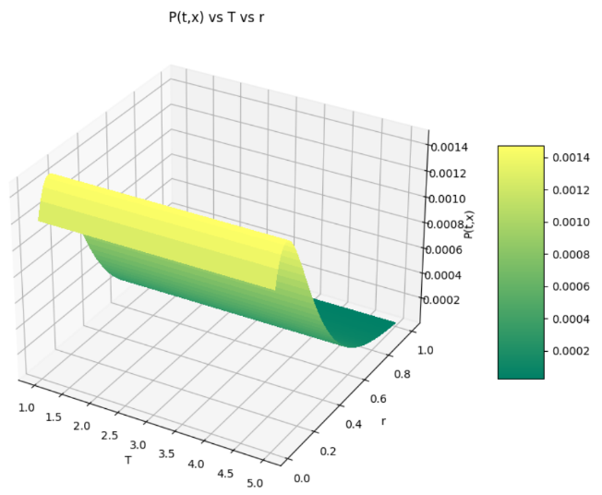**Variation of C(t,s) and P(t,s) with Expiry Time (T) and Rate of Interest (r):**

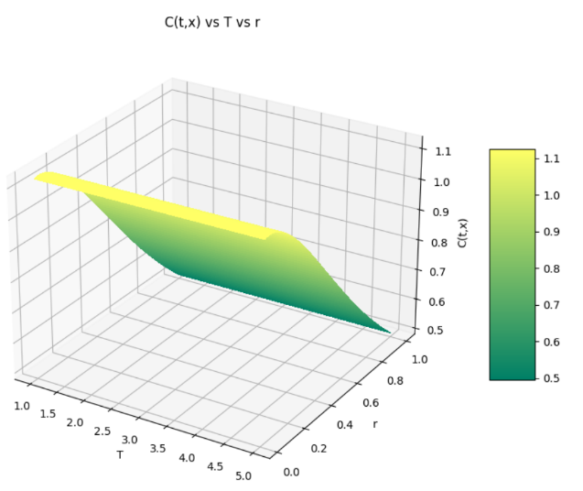

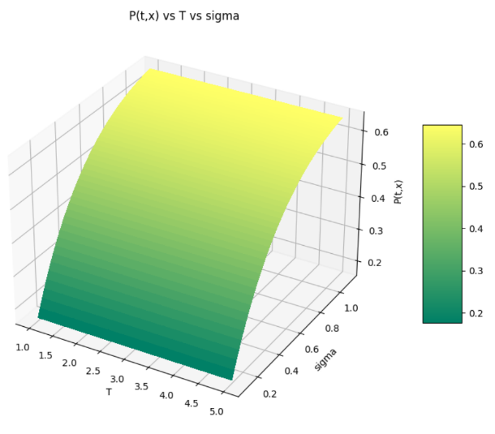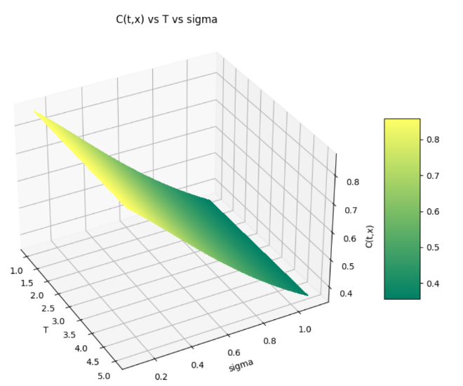**Variation of C(t,s) and P(t,s) with Expiry Time (T) and Volatility (sigma):**

**Variation of C(t,s) and P(t,s) with Expiry Time (T) and Dividend (a):**

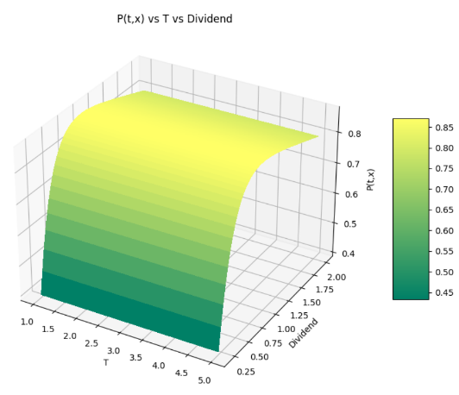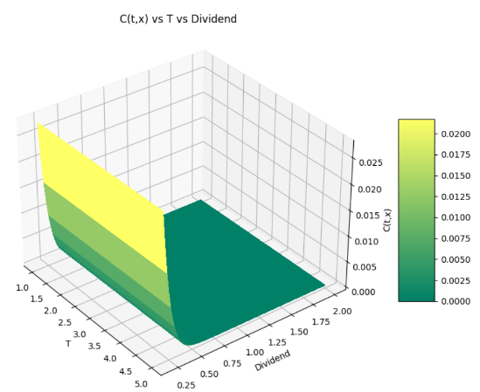

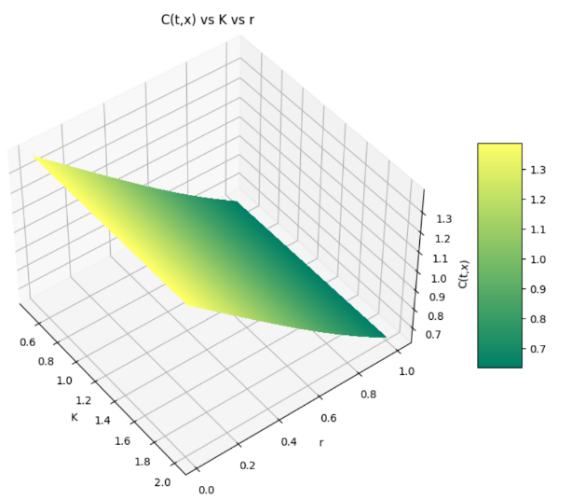**Variation of C(t,s) and P(t,s) with Strike Price (K) and Rate of Interest (r):**

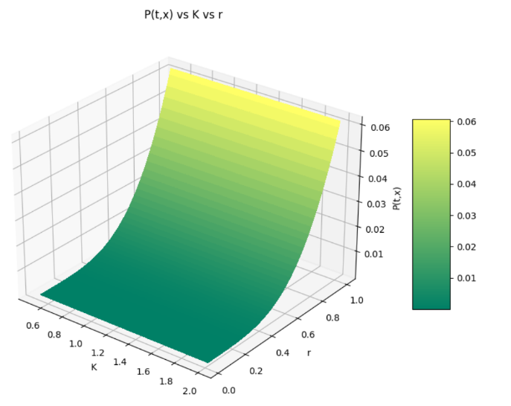

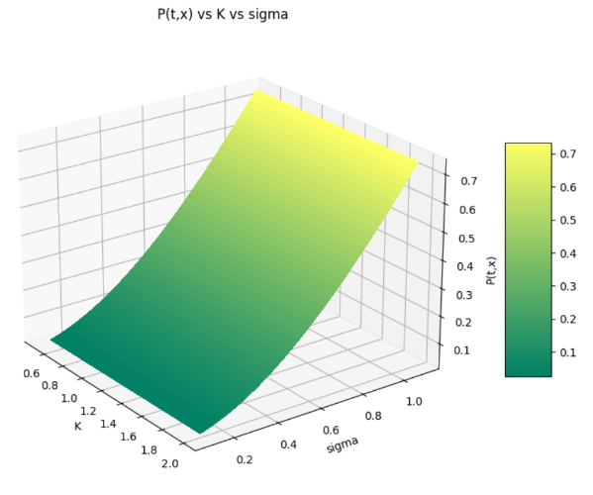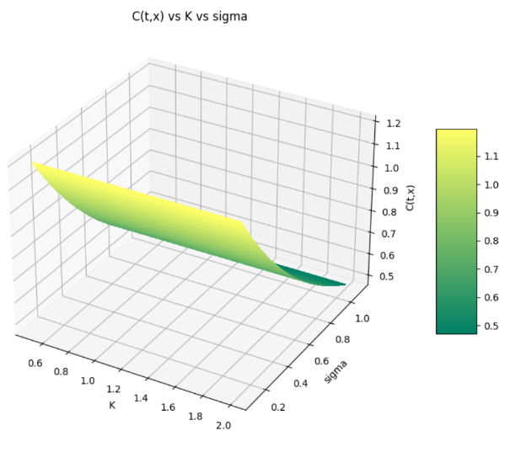**Variation of C(t,s) and P(t,s) with Strike Price (K) and Volatility (sigma):**

**Variation of C(t,s) and P(t,s) with Strike Price (K) and Dividend (a):**

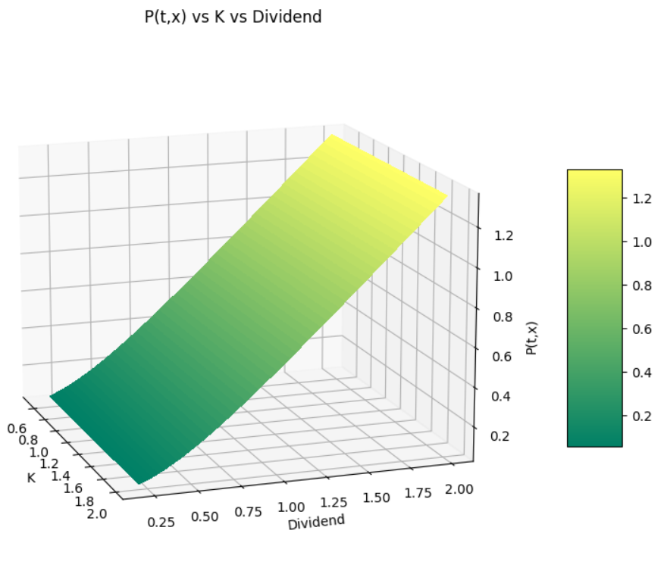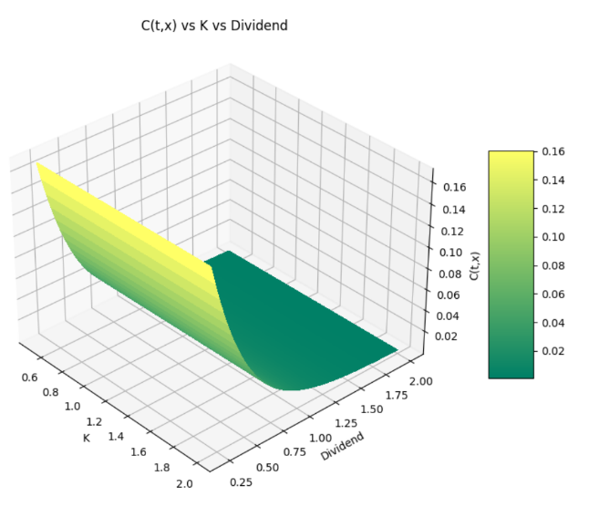

**Variation of C(t,s) and P(t,s) with Rate of Interest (r) and Volatility (sigma):**

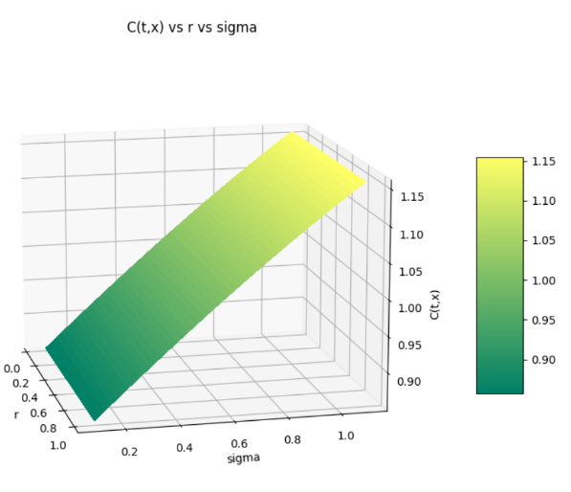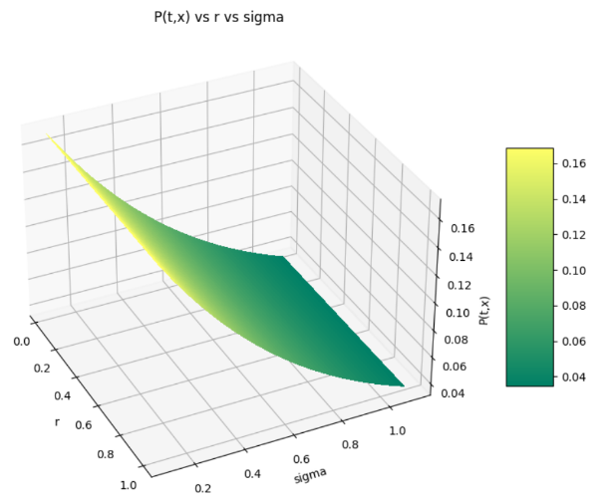

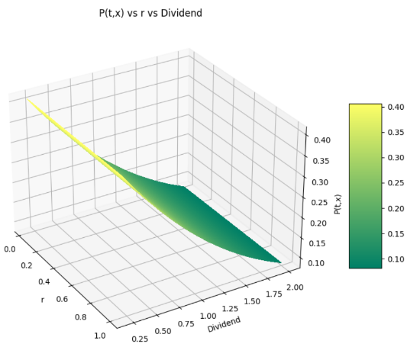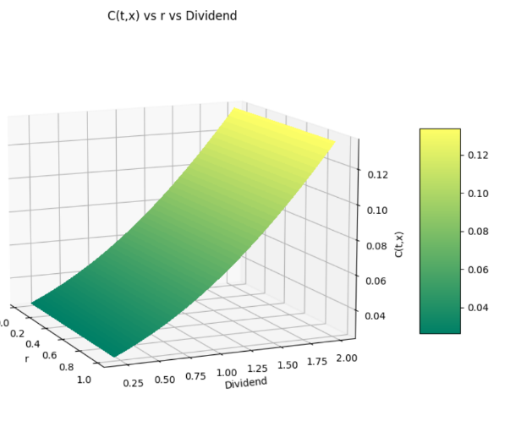**Variation of C(t,s) and P(t,s) with Rate of Interest (r) and Dividend (a):**

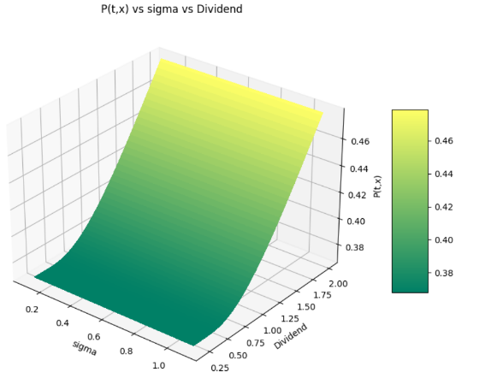**Variation of C(t,s) and P(t,s) with Volatility (sigma) and Dividend (a):**

